**Dependence of Exciton Transport on Solvent Quality in Conjugated Polymer Nanoparticles**

Louis C. Groff, Yifei Jiang, Xiaoli Wang, and Jason D. McNeill

**KEYWORDS**

Diffusion, Energy Transfer, Lattice Gas Model, Swelling, Anisotropy

**ABSTRACT**

The effect of varying solvent quality on observed quenching phenomena and exciton dynamics of conjugated polymer nanoparticles was investigated by steady-state and time-resolved fluorescence spectroscopy. A lattice gas model incorporating exciton diffusion and energy transfer was employed to elucidate the relationship between structural swelling and reduction in quenching by defects. Time-resolved fluorescence anisotropy decay was measured to further determine exciton diffusion parameters. The results indicate highly efficient quenching in poor solvent conditions, which was reversed completely at high THF concentrations. Steady-state and time-resolved data suggest that the nanoparticles and free polymer coexist for both PFBT and MEH-PPV at a narrow range of THF concentrations. The simulation results show good agreement with experimental data prior to nanoparticle dissociation. Fluorescence anisotropy decay results indicate that ~32 exciton hops occur within the lifetime of the swelled nanoparticles and ~3 hops occur within the lifetime of PFBT in THF.

**INTRODUCTION**

Conjugated polymers have, and continue to garnish a great deal of attention, owing to their applications to low-cost photovoltaic and light emitting diode technologies.1,2 Conjugated polymer nanoparticles (CPNs) are well-suited biological imaging applications, given their extraordinary photostability, brightness, and two-photon cross-sections, as well as their ability to be functionalized for cellular uptake.3-9 CPNs are also of interest as a model multi-chromophore system, a model system for coupled spins, or a model quantum mechanical spin glass.10 In order to better utilize conjugated polymers for these applications, it is necessary to delve deeper into the complex photophysics exhibited by these materials, as they are sensitive to polymer structure and processing conditions. The principal neutral photoexcitation in conjugated polymers is the Frenkel exciton.11,12 Energy transfer in conjugated polymers typically occurs via incoherent, diffusion-like processes,13-15 dispersive transport,16 and in certain cases, by long-range coherent transport.17 It has been demonstrated that conjugated polymers exhibit excellent Förster transfer to both dye and polymer dopants, allowing for red shifted emission in imaging applications.18-20 Excitations are delocalized along several chromophores, each typically consisting of several monomer units. Exciton diffusion occurs via transition dipole mediated Förster energy transfer to adjacent chromophores.21 Excitons may be quenched by dopant species, nonfluorescent defect sites, photogenerated hole polarons, or aggregate species, including H and J-aggregates, excimers, and exciplexes.22-27 Chromophore density in conjugated polymers is mainly a result of the structure that chains adopt as a result of their solvent environment. It is understood that abrupt introduction into a poor solvent environment such as water results in chain collapse, where the polymer chains seek to adopt conformations that minimize energetic contributions by surface tension, resulting in either spherical or ellipsoidal nanoparticles, depending on size.28 Chromophore density is greatly increased as a result, which facilitates exciton diffusion. As solvent quality is increased gradually, the entangled chain structures of CPNs swell, and eventually cause nanoparticle dissociation. We have found that nanoparticle swelling and dissociation leads to a two-state system prior to complete dissociation, evidenced by steady state spectra and time resolved lifetime data. A similar conjugated polymer system has been shown to exhibit two-state lifetime dynamics as a function of temperature.29 Another useful question to probe in these systems is the relative measure of how many exciton hops occur within the mean excited state lifetime. This can be assessed using fluorescence anisotropy decay in conjunction with more typical lifetime methods.30

**EXPERIMENTAL METHODS**

**Materials.** The copolymer poly[(9,9-dioctylfluorenyl-2,7-diyl)-*co*-(1,4-benzo-{2,1',3}-thiadiazole)] (PFBT, MW 10,000, polydispersity 1.7), and the poly(phenylene vinylene) derivative poly[2-methoxy-5-(2-ethylhexyloxy)-1,4-phenylenevinylene] (MEH-PPV, MW 200,000, polydispersity, 4.0) were purchased from ADS Dyes, Inc. (Quebec, Canada). The fluorescent dye fluorescein was purchased from Life Technologies (Invitrogen, Eugene, OR). The fluorescent dye Lucifer Yellow CH dipotassium salt (LY, 1 mg/mL in water), solvent tetrahydrofuran (THF, anhydrous, inhibitor-free, 99.9%) and sodium hydroxide (SigmaUltra, minimum 98%) were purchased from Sigma-Aldrich (Milwaukee, WI). All materials were used without further purification.

**Nanoparticle Preparation.** The preparation of fluorescent nanoparticles was performed via a previously described nano-precipiation method.31 The conjugated polymers PFBT and MEH-PPV were dissolved in THF by gentle agitation and prepared at a concentration of 1000 ppm. An aliquot of each stock solution was used to prepare precursor solutions at 20 ppm. A 2 mL quantity of a given precursor solution was rapidly added into 8 mL of deionized water under bath sonication at a frequency of 40 kHz and room temperature. Removal of THF was accomplished by the following procedure. Nanoparticle suspensions were placed in a vacuum oven and pumped down to an atmosphere of -27 in. Hg. The samples were kept at room temperature for one hour to prevent bumping, followed by heating at ~40 °C for 8-10 hours to remove the remaining THF. The aqueous samples were vacuum filtered through a glass fiber prefilter to remove larger aggregates and a 0.1 µm PVDF membrane filter (Millipore). The resulting suspensions are clear (not turbid) and stable for months with no visible signs of aggregation.

**Characterization Methods.** UV-Vis absorption spectra were acquired using a Shimadzu UV2101PC scanning spectrophotometer with 1 cm quartz cuvettes. Fluorescence spectra and fluorescence quantum yield were measured using a commercial fluorimeter (Quantamaster, Photon Technology International) using 1 cm quartz cuvettes.

Picosecond fluorescence lifetimes and fluorescence anisotropy decay (FAD) were measured under nitrogen using a home-built setup for time-correlated single photon counting (TCSPC) spectroscopy operating in reverse mode. Frequency doubled pulses (420 nm) from a passively mode-locked Ti:Sapphire laser (Coherent Mira 900, 840 nm pulses, ~150 fs pulsewidth) were used as the excitation source for the nanoparticle samples. Sample emission was collected with perpendicular geometry to the excitation source after passing through a 460 nm long pass filter, and a Glan-Taylor polarizer (Thorlabs, GT10-A) oriented either parallel (0°), perpendicular (90°), or at magic angle (55°) to the vertically polarized excitation pulses. All three polarization angles were utilized for FAD, magic angle polarizer orientation was adopted for TCSPC. The output of a single photon avalanche photodiode (APD, id Quantique, id100-50) resulting from detection of single fluorescence photons was used as the start timing pulse for a time-to-amplitude converter (TAC, Canberra Model 2145). The output of a fast PIN diode (Thorlabs, DET210) was used as the stop pulse. The excitation intensity was attenuated (usually between ~300 µW and 1 mW) to maintain a raw count rate on the APD of ~400 kHz for TCSPC. For FAD, the excitation intensity is kept ~300-400 µW. The emission intensity yields between 200 kHz and 800 kHz raw APD counts depending on the sample and polarizer orientation. The analog TAC output was digitized using a multi-channel analyzer (FastComTec, MCA-3A). Before and after each measurement, an instrument response function (IRF) was measured using scattered excitation light from a dilute suspension of polystyrene microspheres. The width of the IRF was determined to be ~70 ps (fwhm). Typical signal-to-noise ratios (SNR) were between 200:1 (80%-100% THF samples) and 500:1 (IRF and low-mid % THF samples).

**Swelling Procedure.** In addition to nanoparticles in water and polymer in THF, swollen nanoparticle samples were prepared by diluting an aliquot of concentrated nanoparticle suspension with the appropriate volume of water, then THF to produce a 3 mL solution with volume ratios of THF/water between 0.2 and 0.95. Each sample was gently agitated to ensure solution homogeneity. The sample absorbance was kept at or under ~0.05 (~0.02 for 95% THF). Samples were purged with nitrogen for ~2 minutes to maximize oxygen removal while minimizing THF losses at higher THF ratios.

**RESULTS/DISCUSSION**

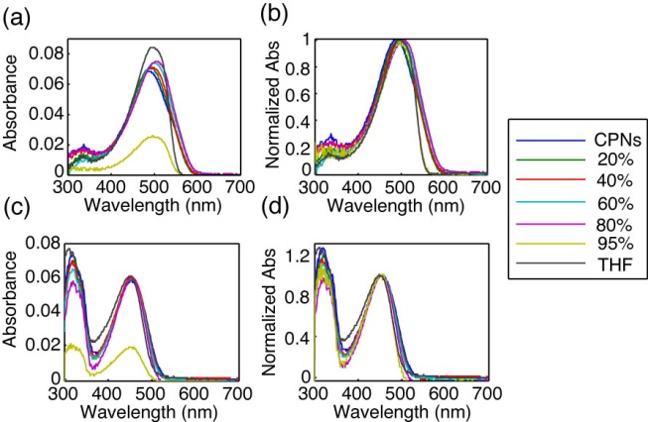

**Fig. 1.** (a,c) Raw and (b,d) normalized absorption spectra of MEH-PPV (top) and PFBT (bottom) at varying volume % THF.

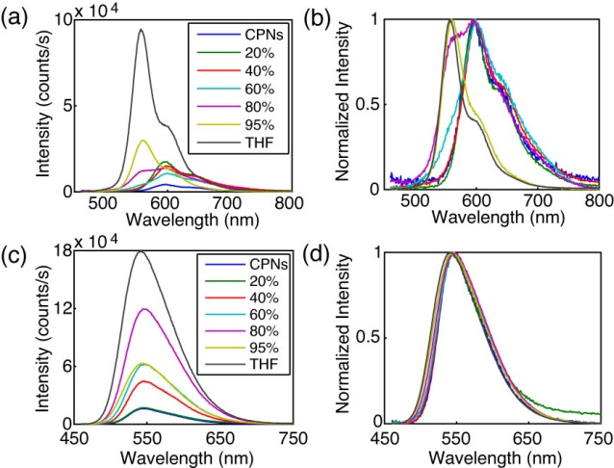

**Fig. 2.** (a,c) Raw and (b,d) normalized emission spectra of MEH-PPV (top) and PFBT (bottom) at varying volume % THF.

**Spectral Analysis of Solvent Quality Data.** The resulting UV-Vis and fluorescence spectra (both normalized and raw) of PFBT and MEH-PPV as a function of solvent quality are given in Figs. 1 and 2. The absorption spectra of PFBT are fairly invariant with increasing THF, with a ~5 nm total blue shift, and slight broadening of the THF sample spectrum. The emission spectra show a monotonic increase in fluorescence intensity as THF concentration increases, and the spectra also exhibit a blue shift ~5 nm over the course of increasing %THF. The absorption spectra of MEH-PPV maintain a similar shape over the course of THF addition, though the 95%-100% THF samples are narrower than the other samples. The absorption peak of MEH-PPV red shifts a total of ~15 nm from 0%-80% THF, and then blue shifts ~7 nm for the high THF samples. The emission peak blue shifts a total of ~40 nm over the course of increasing solvent quality, and it is evident at ~40% THF and higher that there are two phases present in solution by both the increasing blue shoulder on the spectrum, and the reduction in intensity of the red portion of the spectrum. An approximate isosbestic point can be seen ~580 nm at ~80% THF.

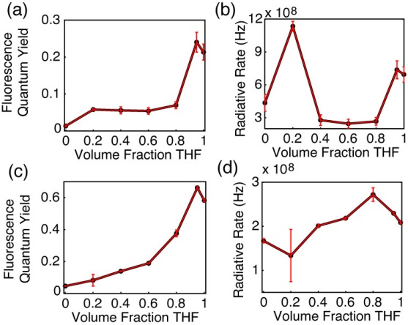

**Fig. 3.** (a,c) Fluorescence quantum yield and (b,d) radiative rate vs. THF volume fraction for MEH-PPV (top) and PFBT (bottom).

The fluorescence quantum yield ( and radiative rate calculations, where the radiative rate is defined as  are given in Fig. 3. The quantum yield of PFBT increases monotonically with increasing THF. However, MEH-PPV shows an initial increase from 0%-20% THF, followed by the quantum yield staying relatively consistent from 20% to 80% THF, then increasing at higher %THF. The higher quantum yield of the 95% sample relative to the polymers in THF is ascribed to the uncertainty in the absorbance at such low concentrations of PFBT and MEH-PPV, though it still falls within normal measurement values. The unvarying quantum yield for MEH-PPV at moderate %THF can be ascribed to the trade-offs in intensity as the blue edge of the spectrum increases and the red edge decreases. The radiative rate varies over a factor of ~2 for PFBT and a factor of ~4 for MEH-PPV over the course of increasing solvent quality. This could suggest that transition dipole coupling is somewhat stronger for MEH-PPV, but neither system is particularly strong.

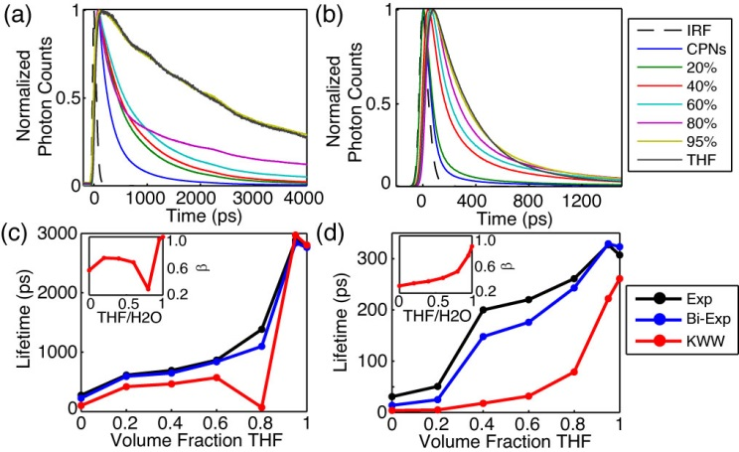

**Fig. 4.** (a,b) Normalized fluorescence intensity decays, and (c,d) lifetimes resulting from single exponential, bi-exponential weighted average, and KWW trial functions with stretch parameter  insets) versus THF volume fraction for PFBT and MEH-PPV, respectively.

**Table 1.** Summary of bi-exponential lifetime Data for MEH-PPV and PFBT CPNs, including weighted average amplitudes and individual exponential time constants.

|  |  |  |  |  |  |  |  |  |
| --- | --- | --- | --- | --- | --- | --- | --- | --- |
| **%(v/v) THF** | **MEH-PPV** | | | | **PFBT** | | | |
| **Amp1** | **1 (ps)** | **Amp2** | **2 (ps)** | **Amp1** | **1 (ps)** | **Amp2** | **2 (ps)** |
| **0** | 0.964 | 9 | 0.036 | 152 | 0.593 | 88 | 0.407 | 421 |
| **20%** | 0.931 | 14 | 0.069 | 176 | 0.513 | 261 | 0.487 | 941 |
| **40%** | 0.734 | 56 | 0.266 | 401 | 0.507 | 277 | 0.493 | 1029 |
| **60%** | 0.749 | 74 | 0.251 | 482 | 0.554 | 364 | 0.446 | 1427 |
| **80%** | 0.752 | 120 | 0.248 | 616 | 0.649 | 231 | 0.351 | 2700 |
| **95%** | 0.795 | 218 | 0.205 | 761 | 0.024 | 234 | 0.976 | 2905 |
| **100%** | 0.949 | 271 | 0.051 | 1287 | 0.006 | 266 | 0.994 | 2778 |

**Picosecond Lifetime Spectroscopy.** Reverse-mode TCSPC obtained at magic angle to the excitation source was employed to measure the excited state lifetimes of both CPN systems over the range of solvent quality. The trial functions employed during iterative reconvolution fitting analysis were single exponential, bi-exponential, and the Kolrausch-Williams-Watts (KWW) function or stretched exponential, given by , where ** is the stretch parameter. Values for ** are typically between ~0.3 and 1, where lower values correspond to a broader distribution of lifetimes for a given sample, and **   corresponds to a single exponential lifetime.32 The fits to all three trial functions converged for all samples. With exception of PFBT in THF which was fit best by a single exponential, the remaining intensity decays fit best to bi-exponential and KWW trial functions. The representative intensity decays for each sample, along with the respective time constants and **versus %THFare given in Fig. 4. The lifetimes for both systems follow a generally increasing trend as solvent quality is improved, and eventually reproduce the lifetime of the free polymer at 95% THF. ** generally increases for both systems, starting from ~0.3 to ~0.7 for MEH-PPV, indicating that even the free polymer exhibits heterogeneity in its lifetime distribution, whereas PFBT varies from ~0.6 to 1. The low values of ** are consistent with the physical picture of energy transfer in multichromophoric systems, and a value of unity is indicative of little or no energy transfer.27 A dramatic decrease in* * from ~0.7 at 60% THF to ~0.3 at 80% THF should be noted for PFBT, and is indicative of a sudden increase in the distribution of exciton lifetimes. This is further explained by a closer inspection of the bi-exponential results.

A breakdown of the bi-exponential fit results is given in Table 1. It can be seen starting at 40% THF for MEH-PPV and 80% THF for PFBT that the individual exponential time constants approximately reproduce the nanoparticle lifetime in 1, and the free polymer lifetime in 2. Thus, the lifetime analysis provides further evidence of a two state-like system, although the weighted amplitudes for MEH-PPV do not display the isosbestic behavior seen in the spectra, and the long time constant continues to increase over the course of THF addition. Conversely, the time constants remain approximately the same for PFBT between 80% – 100%, and the weighted amplitudes show an approximate isosbestic point at 80% THF.

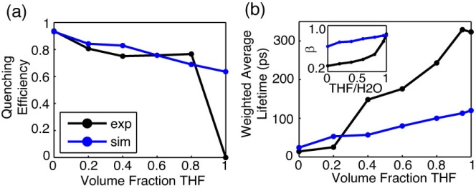

**Fig. 5.** Comparison of simulated (blue) and experimental (black) (a) quenching efficiency, (b) average lifetime, and (inset) KWW stretch parameter *ß* versus THF volume fraction for MEH-PPV.

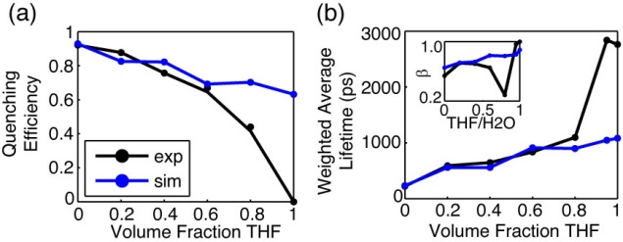

**Fig. 6.** Comparison of simulated (blue) and experimental (black) (a) quenching efficiency, (b) average lifetime, and (inset) KWW stretch parameter *ß* versus THF volume fraction for PFBT.

**Lattice Gas Swelling Model.** Monte Carlo simulations modeling the effect on exciton diffusion/energy transfer by swelling a cubic nanoparticle lattice with a constant number of quenchers were performed for each nanoparticle system. In order to approximate the number of quenchers, here defined as either redshifted or nonfluorescent chromophores, quenchers were added to an unswelled lattice of chromophores until the mean lifetime from 50 simulated nanoparticles (1000 excitons each) was reduced to the lifetime of the nanoparticles in water. In swelling the lattice, the nanoparticle size increased by a swelling factor initially derived from the ratio of swelled/unswelled nanoparticle volumes, given by, where *d* is the swelled lattice spacing, and *x* is the original nanoparticle lattice spacing, calculated to be 1.2 nm for PFBT, and 0.9 nm for MEH-PPV, respectively by taking the cube root of the volume of a single chromophore (taken to be two polymer repeat units). The exciton hopping probability for a random walk is given by , where *t* is the time step, andD is the exciton diffusion constant given by , where  is the lifetime of the polymer in good solvent. This hopping probability was reduced by a factor given by , using the assumption that the hopping probability as a function of lattice spacing is proportional to , where *k* is a constant, typically between 2-4 for excitonic systems, assumed to be 2 for these polymers.12 The time step size was adjusted so that the initial *phop* was ~0.01.

With the assumption that solvent swelling occurs in a similar fashion to other structurally similar polymers such as polystyrene (PS), the increases in the lattice spacing were calculated from data on dye-loaded PS beads swelled with THF.33 The number of quenchers for each polymer (assuming a quencher similar to perylene red with a quenching radius of 4 nm) was determined to be 9 for PFBT, and 10 for MEH-PPV. The greater number of quenchers per CPN than those previously reported for dye-doped PFBT CPNs can be ascribed to the use of a discrete lattice gas model with fixed hop distances as opposed to a continuum model with random hop distances.18 Generally, for both polymers, the single and bi-exponential fits to the simulated decays, as well as the quenching efficiency match the data very in the region of solvent quality where we assume that the polymer chains exist predominantly as a nanoparticle, and deviates substantially in the region of solvent quality where we assume that nanoparticles and free polymer are coexisting in the solution (whether in a dynamic equilibrium or as two distinct phases). The stretched exponential parameters of the experimental PFBT data are reproduced in a similar fashion, matching well for the data at < 80% THF, and deviating at higher % THF. The simulated KWW time constants are somewhat higher for MEH-PPV, and *ß* is ~2x higher than the experimental MEH-PPV data. It is expected that the model data will diverge from the experimental data at higher THF volumes, given that the model does not simulate nanoparticle dissociation.

The difference in quenching efficiency for a 3D PFBT particle (~92%) was compared to the quenching efficiency of a 1D chain of contour length  where *Nchain* is the number of PFBT chains per 10 nm dia. particle, and *Lchain* is the approximate contour length of one chain of PFBT at the relevant molecular weight. A number of Poisson distributed quenchers equal to the quantity obtained via simulation results were incorporated into the chain. The total quenched contour length results in ~9% quenching, which supports the notion that even with the same quantity of quenchers in the system, quenching is greatly suppressed as the nanoparticle dissociates.

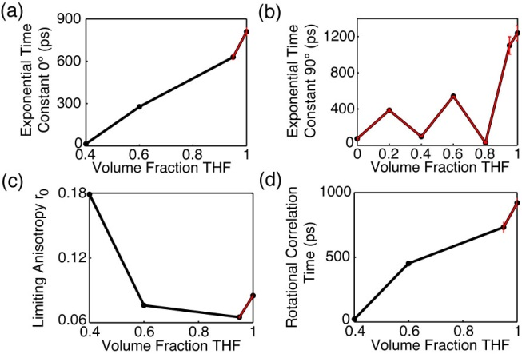

**Fig. 7.** (a,b) Single exponential time constants for parallel (0°) and perpendicular (90°) intensity decays of PFBT. (c,d) Limiting anisotropy and rotational correlation time of PFBT as a function of THF volume fraction.

**Picosecond Fluorescence Anisotropy Decay (FAD).** TCSPC was employed to measure polarized fluorescence intensity decays in order to calculate time-resolved anisotropy decay parameters. The process by which the anisotropy data is calculated from the fluorescence intensity decays at each polarizer orientation is given as follows. First, the total intensity decay law is determined from fitting the 55° data (the trial functions are single exponential for fluorescein in water and PFBT in THF, and KWW for the CPN samples). The parameters yielded from these fits (, or , *β*) are used as the first term of the trial decay for the 0° and 90° data. The second term in the trial decay function for the parallel or perpendicular data is given by a single exponential, so that the total trial decay function for a given sample is either a bi-exponential or a summed KWW and exponential decay

, (1)

where the superscript indicates the polarizer orientation. The fit results are then processed to determine the rotational correlation time , and the limiting anisotropy  as follows. First, an amplitude correction factor, used to account for differences in SNR from run to run between the 55° data and the 0° (or 90°) data, is determined by**, where the corrected amplitude (LHS) is calculated by multiplying the amplitude of the second exponential term in Equation 1 by the ratio of the 55° and the 0° (or 90°) KWW amplitudes. Thus, the corrected amplitude replaces the amplitude on the second term in Equation 1.Once the amplitudes are corrected, the rotational correlation time is calculated by a weighted average of the 0° and 90° lifetimes,

. (2)

In calculating r(t), the 55° terms drop out in the numerator due to the subtraction of I0(t) and I90(t), yielding

. (3)

Evaluating Equation 3 at t = 0 yields the limiting anisotropy ,

.  (4)

While complete anisotropy data was unable to be obtained for all except the highest % THF MEH-PPV samples (*r*0 = 0.07 r = 293 ps), owing to the fact that the majority of its anisotropy decays below the time resolution of our instrument,34 anisotropy data for PFBT is given in Fig. 7. The rotational correlation time shows a general increasing trend, which reflects the parallel and perpendicular time constants from which r is calculated, indicating that the anisotropy decays more slowly as the volume fraction of THF increases. This is expected due to a reduction in exciton diffusion as the interchromophore distance increases due to swelling, and anisotropy loss is largely due to diffusive motion in good solvent. The low (~2x to ~50x lower than 0.4) limiting anisotropy values obtained for PFBT suggest that there is more anisotropy information at earlier times, below the time resolution of our instrument. Using the ratio of fluorescence lifetime to rotational correlation time, we can obtain an estimate of the number of exciton hops that occur within the mean exciton lifetime.30 For the case of PFBT CPNs in 40% THF (given that more anisotropy is observed for this sample, *r*0 = 0.18), the exciton lifetime is ~650 ps, and the rotational correlation time is ~20 ps. This corresponds to approximately 32 hops within the lifetime of each exciton. Compared to the free polymer in THF, with exp ~2800 ps and r ~900 ps, this corresponds to ~3 hops per lifetime, providing further evidence that exciton diffusion is favored in the aggregated state.

**CONCLUSION**

The solvent quality dependence of photophysical parameters of PFBT and MEH-PPV CPNs was assessed. The quantum yield of both systems increases with increasing THF concentration, eventually reproducing the quantum yield for free polymer at 95% THF. Spectral data of MEH-PPV exhibits significant blue shifting as solvent quality is improved, with an approximate isosbestic point between the nanoparticle and free polymer spectra of 80% THF. Bi-exponential lifetime data suggests an isosbestic point of 80% for PFBT, and 40% for MEH-PPV. A lattice gas exciton diffusion, energy transfer model yielded 9 and 10 quenchers/particle for PFBT and MEH-PPV respectively, with good agreement to experimental data at THF concentrations where nanoparticle dissociation is not prominent. Time-resolved fluorescence anisotropy decay analysis allowed for the determination of the number of exciton hops per lifetime of ~32 for swelled PFBT CPNs and ~3 hops for PFBT in THF, supporting the notion that exciton diffusion is effectively shut down in good solvent.

**ACKNOWLEDGMENTS**

We acknowledge financial support from the NSF under Grant No. CHE-1058885.

**REFERENCES**

(1) Dennler, G., and Sariciftci, N. S. Flexible Conjugated Polymer-Based Plastic Solar Cells: From Basics to Applications. *Proc. IEEE* **2005**, *93*, 1429-1439.

(2) Yim, K. H., Zheng, Z., Liang, Z., Friend, R. H., Huck, W. T. S., and Kim, J. S. Efficient Conjugated-Polymer Optoelectronic Devices Fabricated by Thin-Film Transfer-Printing Technique. *Adv Funct Mater* **2008**, *18*, 1012-1019.

(3) Wu, C. F.; Szymanski, C.; Cain, Z.; McNeill, J. Conjugated Polymer Dots for Multiphoton Fluorescence Imaging. *J. Am. Chem. Soc.* **2007**, *129*, 12904-12905.

(4) Yu, J., Wu, C. F., Sahu, S. P., Fernando, L. P., Szymanski, C., and McNeill, J. Nanoscale 3D Tracking with Conjugated Polymer Nanoparticles. *J. Am. Chem. Soc.* **2009**, *131*, 18410-18414.

(5) Wu, C. F., Bull, B. Christensen, K. and McNeill, J. Ratiometric Single-Nanoparticle Oxygen Sensors for Biological Imaging. *Angew. Chem., Int. Ed.* **2009**, *48*, 2741-2745.

(6) Wu, C. F.; Bull, B.; Szymanski, C.; Christensen, K.; McNeill, J. Multicolor Conjugated Polymer Dots for Biological Fluorescence Imaging. *ACS Nano* **2008**, *2*, 2415-2423.

(7) Wu, C. F.; Schneider, T.; Zeigler, M.; Yu, J. B.; Schiro, P. G.; Burnham, D. R.; McNeill, J. D.; Chiu, D. T. Bioconjugation of Ultrabright Semiconducting Polymer Dots for Specific Cellular Targeting. *J. Am. Chem. Soc.* **2010**, *132*, 15410-15417.

(8) Wu, C. F.; Chiu, D. T. Highly Fluorescent Semiconducting Polymer Dots for Biology and Medicine. *Angew. Chem., Int. Ed.* **2013**, *52*, 3086-3109.

(9) Koner, A. L.; Krndija, D.; Hou, Q.; Sherratt, D. J.; Howarth, M. Hydroxy-Terminated Conjugated Polymer Nanoparticles Have Near-Unity Bright Fraction and Reveal Cholesterol-Dependence of IGF1R Nanodomains. *ACS Nano* **2013**, *7*, 1137-1144.

(10) Read, N.; Sachdev, S.; Ye, J. Landau Theory of Quantum Spin-Glasses of Rotors and Ising Spins. *Phys. Rev. B* **1995**, *52*, 384-410.

(11) Kasha, M.; Rawls, H. R.; Ashraf El-Bayoumi, M. The Exciton Model in Molecular Spectroscopy. *Pure and Applied Chemistry* **1965**, *11*, 371-392.

(12) Emelianova, E. V., Athanasopoulos, S., Silbey, R. J., and Beljonne, D. 2D Excitons as Primary Energy Carriers in Organic Crystals: The Case of Oligoacenes. *Phys. Rev. Lett.* **2010**, *104*, 206405-206408.

(13) Lunt, R. R., Giebink, N. C., Belak, A. A., Benzinger, J. B., and Forrest, S. R. Exciton Diffusion Lengths of Organic Semiconductor Thin Films Measured by Spectrally Resolved Photoluminescence Quenching. *J. Appl. Phys.* **2009**, *105*, 053711-053717.

(14) Gammill, L. S.; Powell, R. C. Energy-Transfer in Perylene Doped Anthracene-Crystals. *Mol. Cryst. Liq. Cryst.* **1974**, *25*, 123-130.

(15) Powell, R. C.; Kepler, R. G. Evidence for Long-Range Exciton-Impurity Interaction in Tetracene-Doped Anthracene Crystals. *Phys. Rev. Lett.* **1969**, *22*, 636-639.

(16) Athanasopoulos, S.; Hoffman, S. T.; Bassler, H.; Kohler, A.; Beljonne, D. To Hop or Not to Hop? Understanding the Temperature Dependence of Spectral Diffusion in Organic Semiconductors. *J. Phys. Chem. Lett.* **2013**, *4*, 1694-1700.

(17) Scholes, G. D., and Rumbles, G. Excitons in Nanoscale Systems. *Nature Materials* **2006**, *5*, 683-696.

(18) Groff, L. C.; Wang, X. L.; McNeill, J. D. Measurement of Exciton Transport in Conjugated Polymer Nanoparticles. *J. PHys. Chem. C* **2013**, *117*, 25748-25755.

(19) Wang, X. L.; Groff, L. C.; McNeill, J. D. Photoactivation and Saturated Emission in Blended Conjugated Polymer Nanoparticles. *Langmuir* **2013**, *29*, 13925-13931.

(20) Sun, K.; Chen, H.; Wang, L.; Yin, S.; Wang, H.; Xu, G.; Chen, D.; Zhang, X. J.; Wu, C. F.; Qin, W. P. Size Dependent Property and Cell Labeling of Semiconducting Polymer Dots. *ACS Appl. Mater. Interf.* **2014**, *In Press*.

(21) Burkalov, V. M., Kawata, K., Assender, H. E., Briggs, G. A. D., Ruseckas, A., and Samuel, I. D. W. Discrete Hopping Model of Exciton Transport in Disordered Media. *Phys. Rev. B* **2005**, *72*, 075206-075210.

(22) Jelly, E. E. Molecular, Nematic and Crystal States of I: I-Diethyl--Cyanine Chloride. *Nature (London)* **1936**, *139*, 631-632.

(23) Hayer, A., Van Regemorter, T., Höfer, B., Mak, C. S. K., Beljonne, D., and Köhler, A. On the Formation Mechanism for Electrically Generated Exciplexes in a Carbazole-Pyridine Copolymer. *J. Polym. Sci. Part B: Polym. Phys.* **2012**, *50*, 361-369.

(24) McNeill, J. D.; Barbara, P. F. NSOM Investigation of Carrier Generation, Recombination, and Drift in a Conjugated Polymer. *J. PHys. Chem. B* **2002**, *106*, 4632-4639.

(25) Hintschich, S. I.; Rothe, C.; Sinha, S.; Monkman, A. P.; de Freitas, P. S.; Scherf, U. Population and Decay of Keto States in Conjugated Polymers. *J. Chem. Phys.* **2003**, *119*, 12017-12022.

(26) Wu, C. F., Peng, H., Jiang, Y. and McNeill, J. Energy Transfer Mediated Fluorescence from Blended Conjugated Polymer Nanoparticles. *J. PHys. Chem. B* **2006**, *110*, 14148-14154.

(27) Wu, C. F., Zheng, Y. L., Szymanski, C., and McNeill, J. Energy Transfer in a Nanoscale Multichromophoric System: Fluorescent Dye-Doped Conjugated Polymer Nanoparticles. *J. PHys. Chem. C* **2008**, *112*, 1772-1781.

(28) Yang, Z.; Huck, W. T. S.; Clarke, S. M.; Tajbakhsh, A. R.; Terentjev, E. M. Shape-Memory Nanoparticles from Inherently Non-Spherical Polymer Colloids. *Nature Materials* **2005**, *4*, 486-490.

(29) Dias, F. B.; Macanita, A. L.; de Melo, J. S.; Burrows, H. D.; Guntner, R.; Scherf, U.; Monkman, A. P. Picosecond conformational relaxation of singlet excited polyfluorene in solution. *J. Chem. Phys.* **2003**, *118*, 7119-7126.

(30) Martini, M.; Roux, S.; Montagna, M.; Pansu, R.; Julien, C.; Tillement, O.; Perriat, P. How gold inclusions increase the rate of fluorescein energy homotransfer in silica beads. *Chem Phys Lett* **2010**, *490*, 72-75.

(31) Szymanski, C., Wu, C. F., Hooper, J., Salazar, M. A., Perdomo, A., Dukes, A., and McNeill, J. Single Molecule Nanoparticles of the Conjugated Polymer MEH-PPV, Preparation and Characterization by Near-Field Scanning Optical Microscopy. *J. PHys. Chem. B* **2005**, *109*, 8543-8546.

(32) Chen, R. Apparent Stretched-Exponential Luminescence Decay in Crystalline Solids. *J. Lumin.* **2003**, *102*, 510-518.

(33) Lee, J. H.; Gomez, I. J.; Sitterle, V. B.; Meredith, J. C. Dye-labeled polystyrene latex microspheres prepared via a combined swelling-diffusion technique. *J Colloid Interf Sci* **2011**, *363*, 137-144.

(34) Collini, E.; Scholes, G. D. Coherent Intrachain Energy Migration in a Conjugated Polymer at Room Temperature. *Science* **2009**, *323*, 369-373.